UNIVERSITI TEKNOLOGI MALAYSIA
Faculty of Computing · Department of Software Engineering
SCSE2233 – Software Design and Architecture · Semester 2, 2025/2026 · Section 3
SOFTWARE DESIGN DESCRIPTION (SDD)
Online Food Delivery System
Final Project — Master Consolidated SDD (Assignment 3)
Version 3.0
Prepared by: Group Hub (Group 11)
Lecturer: Dr. Muhammad Khatibsyarbini
Team Member | Matric No. | Role | Module
Mohammed Mohsen Mohammed Alsakkaf | A23CS4026 | Lead Architect & Project Manager | M1 — User Auth & Restaurant Browsing
Anas Ahmed Hisham | A24CS4006 | System Analyst | M2 — Shopping Cart & Order Placement
Imtiaj Ahmed | A24CS4017 | Interface Designer | M3 — Payment Processing & Delivery Tracking

Deadline: 3–4 July 2026 · Architectural style: Microservices · Framework: IEEE Std 1016-2009

1. Frontispiece

1.1 Overview
This document is Version 3.0 of the Software Design Description (SDD) for the Online Food Delivery System — the consolidated Master SDD delivered as the Final Project. It encapsulates rather than replaces the two earlier deliverables: the Assignment 1 architectural blueprint (use case model, per-module UML, and the microservices style) and the Assignment 2 engine (one creational, one structural, and one behavioural design pattern per module, with Java translated from the UML). On top of that foundation, Version 3.0 adds the three detailed member-owned viewpoints demanded by the Final Project — the Information viewpoint (per-module ERDs, §5.4), the Algorithmic viewpoint (decision tables, §5.8), and the Interface viewpoint (per-feature wireframes, §5.5) — an extended code implementation (§5.6), and an end-to-end traceability matrix (§6) that proves every UI control descends through a decision table and a design pattern to executable code.

1.2 Issuing Team
Issued by Group Hub (Group 11), Faculty of Computing, Universiti Teknologi Malaysia, for the SCSE2233 course. The team owns the end-to-end design of the Online Food Delivery System, partitioned into three independently designed and independently deployable modules — one per member.

1.3 Authorship / Project Team Members
Name | Matric No. | Role | Module (individual scope) | Status
Mohammed Mohsen Mohammed Alsakkaf | A23CS4026 | Lead Architect & Project Manager | M1 — User Auth & Restaurant Browsing | Complete
Anas Ahmed Hisham | A24CS4006 | System Analyst | M2 — Shopping Cart & Order Placement | Complete
Imtiaj Ahmed | A24CS4017 | Interface Designer | M3 — Payment Processing & Delivery Tracking | Complete

1.4 Revision History
Rev. | Issue Date | Details of Revision
1.0 | May 2026 | Assignment 1: case study, use case diagram and specifications, sequence diagrams, microservices architectural style, per-module UML class diagrams.
2.0 | June 2026 | Assignment 2: Information/Interface/Algorithm viewpoints (initial), one creational + one structural + one behavioural pattern per module, pattern-aware class & sequence diagrams, Java code samples, coherence-validation tables.
3.0 | July 2026 | Final Project (Master SDD): consolidation of A1+A2; per-module ERDs & data dictionaries; per-module decision tables; per-feature wireframes mapped to logic and data; extended, syntax-highlighted code; and the UI→Decision Table→Pattern→Code traceability matrix.

Table of Contents
1. Frontispiece 2
1.1 Overview 2
1.2 Issuing Team 2
1.3 Authorship / Project Team Members 2
1.4 Revision History 2
2. Introduction 5
2.1 Purpose 5
2.2 Scope 5
2.3 Context 5
2.4 Summary 5
3. References 7
4. Glossary 8
5. Design Body 9
5.1 Design Stakeholders and Their Concerns 9
5.2 Context Viewpoint (Use Case Diagram) 9
5.3 Structure Viewpoint (Microservices) 11
5.4 Information Viewpoint — ERDs [Task 2] 12
5.5 Interface Viewpoint — Wireframes [Task 4] 16
5.6 Logical Viewpoint — Patterns & Extended Code [Task 6] 19
5.7 Interaction Viewpoint — Sequence Diagrams 26
5.8 Algorithm Viewpoint — Decision Tables [Task 3] 29
6. Traceability — The Red Thread 35
6.1 Module 1 — Mohammed Alsakkaf 35
6.2 Module 2 — Anas Ahmed Hisham 35
6.3 Module 3 — Imtiaj Ahmed 35
7. User Interface Design 37
8. Appendices 38
8.1 Appendix A — Module Assignment & Pattern Matrix 38
8.2 Appendix B — Group Work Contributions 38
8.3 Appendix C — Project Access & Testing Information 38
8.4 Appendix D — Final QA Flight Check 38

2. Introduction
The following sections provide the complete design of the Online Food Delivery System. The document follows the IEEE 1016 viewpoint model, organising the design as a set of complementary views, each resolving a specific set of stakeholder concerns identified in §5.1.

2.1 Purpose
This SDD specifies the detailed software design of the Online Food Delivery System, evolving the Assignment 1 architecture into an implementation-ready, client-ready blueprint. Its purpose is twofold: to specify how the system’s classes, data, interfaces, and interactions are organised; and to demonstrate the disciplined application of object-oriented design patterns that make the system extensible, maintainable, and ready for coding. The intended audience is:
- Software designers and developers — who implement the modules from the class, sequence, and decision-table specifications and the code samples;
- Software architects — who verify the design honours the microservices style and the non-functional requirements;
- Quality-assurance engineers — who derive test cases from the use cases, decision tables, and sequence diagrams;
- Course evaluator / lecturer — who assesses architectural coherence, correct pattern application, and end-to-end traceability.

2.2 Scope
The software product specified is the Online Food Delivery System — a distributed, multi-actor platform that lets customers discover restaurants, build a cart, place and pay for orders, and track delivery in real time. It is comparable in scope to Grab Food, Foodpanda, and Uber Eats. The system will authenticate users; allow restaurant and menu browsing with search and filtering; manage shopping carts and order placement; process payments securely through an external gateway; and stream live delivery tracking. It will not implement the restaurant-side kitchen-management application, the driver dispatch-optimisation engine, or third-party loyalty programs; these are treated as external systems or out of scope. The design is consistent with the microservices architectural style selected in Assignment 1.

2.3 Context
This SDD is used by the project’s technical and managerial stakeholders. It serves as a guide for the designer in the selection, organisation, and presentation of design information, and as a reference contract between design and implementation. It is intended to be read as the single consolidated deliverable for the Final Project; the Assignment 1 and Assignment 2 reports are subsumed here and need not be read separately.

2.4 Summary
Section 3 lists the references and Section 4 the glossary. Section 5 — the Design Body — presents the eight IEEE 1016 viewpoints: design stakeholders and concerns (5.1); the Context viewpoint with the use case model (5.2); the Structure viewpoint with the microservices architecture and its NFR justification (5.3); the Information viewpoint with per-module ERDs (5.4); the Interface viewpoint with per-feature wireframes (5.5); the Logical viewpoint with the design patterns and extended code (5.6); the Interaction viewpoint with pattern-aware sequence diagrams (5.7); and the Algorithm viewpoint with decision tables and the activity/state models (5.8). Section 6 presents the traceability matrix (the “red thread”). Section 7 consolidates the user-interface design and Section 8 holds the appendices, including the Final QA checklist and project access/testing information.

3. References
[1] IEEE Std 1016-2009, IEEE Standard for Information Technology — Systems Design — Software Design Descriptions. IEEE Computer Society.
[2] IEEE Std 830-1998, IEEE Recommended Practice for Software Requirements Specifications. IEEE Computer Society.
[3] Gamma, E., Helm, R., Johnson, R., & Vlissides, J. (1994). Design Patterns: Elements of Reusable Object-Oriented Software. Addison-Wesley.
[4] Newman, S. (2021). Building Microservices, 2nd ed. O’Reilly Media.
[5] Richards, M. (2020). Fundamentals of Software Architecture: An Engineering Approach. O’Reilly Media.
[6] Group Hub (2026). Software Architecture Design — Assignment 1 (v1.0) and Design Patterns — Assignment 2 (v2.0): Online Food Delivery System. SCSE2233.
[7] UML Diagrams — Examples. https://www.uml-diagrams.org/index-examples.html

4. Glossary
Term | Definition
Adapter | Structural pattern that converts the interface of a class (e.g., an external API) into another interface clients expect.
Builder | Creational pattern that constructs a complex object step by step, separating construction from representation.
Decision Table | Tabular model mapping every combination of conditions to the exact actions the system must take.
ERD | Entity Relationship Diagram — a model of persistent data entities and their relationships.
Facade | Structural pattern providing a unified, simplified interface over a set of subsystems.
Factory Method | Creational pattern that defers object instantiation to subclasses via an overridable creation method.
JWT | JSON Web Token — a signed, self-contained token used for stateless authentication.
Microservices | Architectural style decomposing a system into small, independently deployable services, each owning its data.
Observer | Behavioural pattern in which subscribers are notified automatically of a subject’s state changes.
PCI DSS | Payment Card Industry Data Security Standard — security requirements for handling cardholder data.
Proxy | Structural pattern providing a surrogate (e.g., a cache) that controls access to a real object.
Singleton | Creational pattern ensuring a class has exactly one instance with a global access point.
State | Behavioural pattern that lets an object alter its behaviour when its internal state changes.
Strategy | Behavioural pattern that encapsulates interchangeable algorithms behind a common interface.
WebSocket | Full-duplex protocol over a single TCP connection, used here for live GPS push.

5. Design Body
This section presents the design of the Online Food Delivery System through the IEEE 1016 viewpoints. Each viewpoint resolves a specific set of design concerns held by the stakeholders in §5.1, and the rationale for each viewpoint follows directly from those concerns.

5.1 Design Stakeholders and Their Concerns
An SDD shall address each identified design concern. The table below maps every stakeholder to their primary concerns and to the viewpoint(s) that resolve them.
Design Stakeholder | Primary Design Concerns | Addressing Viewpoint(s)
Customer (end user) | Easy discovery, fast checkout, transparent live tracking, data privacy. | Context (5.2), Interface (5.5), Interaction (5.7)
Software Architect | Adherence to microservices; scalability, fault isolation, security segmentation. | Structure (5.3), Logical (5.6)
Developer | Clear class structure, correct pattern application, code that matches the UML and the logic. | Logical (5.6), Interaction (5.7), Algorithm (5.8)
Database Administrator | Well-normalised persistent data, integrity constraints, clear entity relationships. | Information (5.4)
QA Engineer | Testable flows, defined alternative/exception paths, deterministic decision logic. | Algorithm (5.8), Interaction (5.7), Traceability (6)
Admin / Operations | Restaurant and fleet management, monitoring, low-friction per-service deployment. | Context (5.2), Structure (5.3)
Payment Compliance Officer | PCI DSS isolation; no card data stored on the platform. | Structure (5.3), Logical (5.6 — M3)

5.2 Context Viewpoint (Use Case Diagram) [Group — Task 1]

5.2.1 Design Concerns
The Context viewpoint identifies the services the system offers, the actors that interact with it, and the boundary between the system and its environment. The Online Food Delivery System offers seven primary features — register/login, browse restaurants & menu, add items to cart, place & confirm order, process payment, track delivery, and manage restaurants & fleet. The external actors are the Customer, Delivery Driver, Admin, the Stripe Payment Gateway, and the Email/Notification Service.

5.2.2 Design View
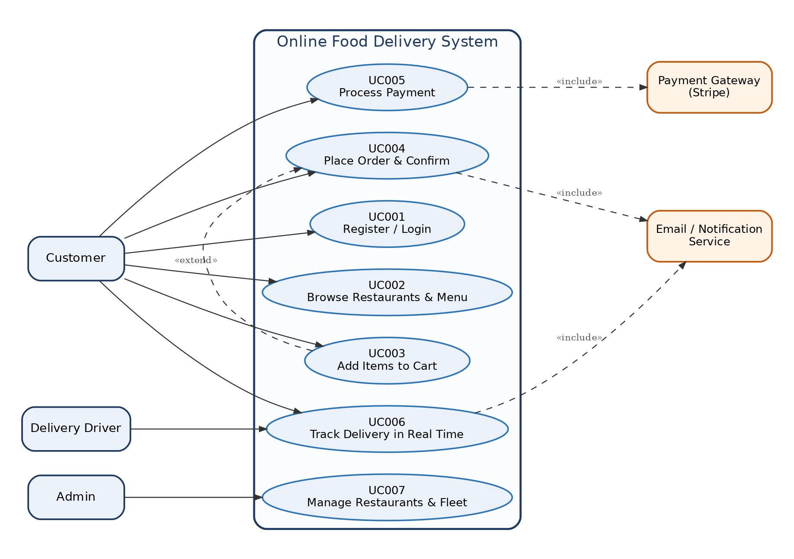
Figure 5.2.1 — Use Case Diagram for the Online Food Delivery System
Actors.
Actor | Type | Description
Customer | Human (primary) | Browses restaurants, places orders, pays, and tracks deliveries.
Admin | Human | Manages restaurant listings and the delivery fleet; monitors analytics.
Delivery Driver | Human (external) | Fulfils active deliveries and updates GPS position.
Payment Gateway (Stripe) | External System | Tokenises cards, processes charges, handles refunds.
Email / Notification Service | External System | Dispatches order confirmations and live status updates.
Use-case-to-module ownership. The seven use cases are partitioned across the three members. Each member’s detailed viewpoints (§5.4–5.8) are labelled with their name and module.
Module / Owner | Use Cases (individual scope)
M1 — Mohammed Alsakkaf | UC001 Register/Login · UC002 Browse Restaurants & Menu
M2 — Anas Ahmed Hisham | UC003 Add Items to Cart · UC004 Place Order & Confirm
M3 — Imtiaj Ahmed | UC005 Process Payment · UC006 Track Delivery in Real Time
Full use-case specifications (main flow, alternative and exception flows) were delivered in Assignment 1 and are realised in this document as the decision tables of §5.8 and the sequence branches of §5.7.

5.3 Structure Viewpoint (Architecture Style — Microservices) [Group — Task 1]

5.3.1 Design Concerns
The Structure viewpoint documents how the system is partitioned into services, how they communicate, and how the architecture satisfies the non-functional requirements (NFRs). Selected style: Microservices. The system is decomposed into small, independently deployable services — each owning its data store and API surface. Services communicate via REST/HTTPS for synchronous calls and an event bus for asynchronous operations (notifications, delivery dispatch); WebSocket is used for live GPS push.
Justification against non-functional requirements.
Non-Functional Requirement | How the Microservices style satisfies it
Scalability — 50,000 concurrent users at peak | RestaurantService auto-scales independently (e.g., 3→15 instances) without touching PaymentService.
Performance — search P99 < 300 ms | RestaurantCacheProxy (Proxy pattern, §5.6.2) serves hot queries from cache, cutting DB load.
Security — PCI DSS; no card data stored | PaymentService runs in an isolated PCI-scoped segment; StripeGatewayAdapter keeps card data off-platform.
Availability — 99.9% uptime | Fault isolation: a DeliveryService outage does not cascade to browsing or payment.
Maintainability — < 1 hour deploy per service | Each module maps to one independently ownable, independently deployable service.

5.3.2 Design View
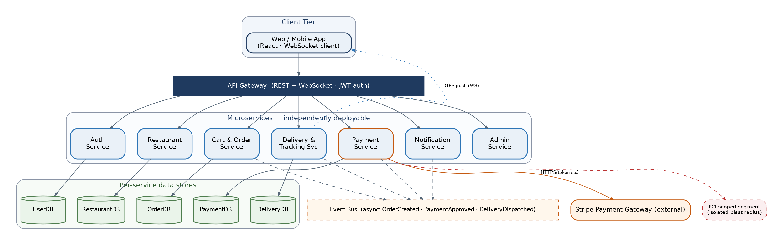
Figure 5.3.1 — Microservices Component Architecture for the Online Food Delivery System

5.4 Information Viewpoint (Database Design — ERDs) [Task 2]

5.4.1 Design Concerns
The Information viewpoint applies because the system has substantial persistent data. It addresses how the information domain is transformed into data structures, how entities are stored and related, and how integrity is preserved. In a microservices deployment each service owns its schema; the per-module ERDs below present the logical data model for each member’s scope, and every entity maps back to a class established in the Assignment 1 UML (the Alignment Check, §5.4.5).

5.4.2 Module 1 — User Auth & Restaurant Browsing | Mohammed Alsakkaf
Core features: User Registration/Login and Restaurant Browsing. The module owns four entities: USER and SESSION (authentication) and RESTAURANT and MENU_ITEM (browsing).
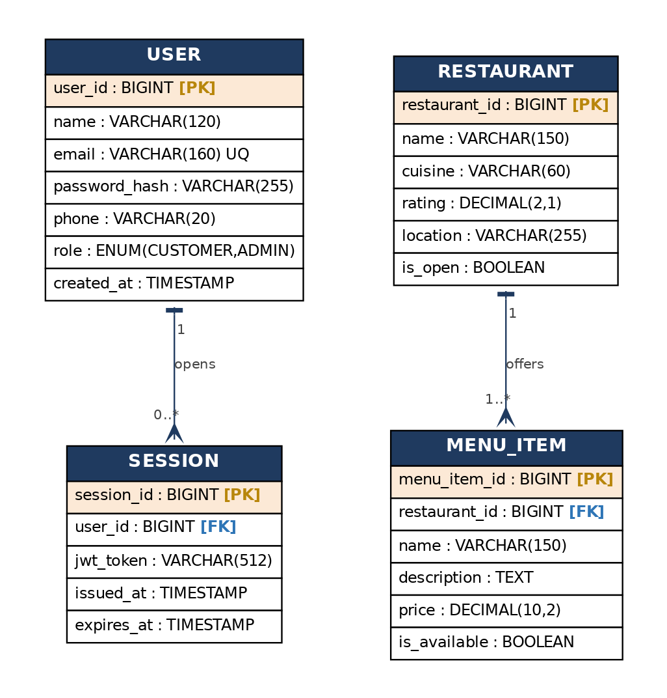
Figure 5.4.1 — ERD for Module 1 (Auth & Restaurant Browsing) — Mohammed Alsakkaf
Data dictionary (selected entities).
Entity | Attribute | Type | Notes
USER | user_id | BIGINT | PK — unique user identifier.
USER | email | VARCHAR(160) | UNIQUE — login identifier.
USER | password_hash | VARCHAR(255) | BCrypt salted hash; never plaintext.
USER | role | ENUM | CUSTOMER or ADMIN.
SESSION | session_id | BIGINT | PK — issued JWT session.
SESSION | user_id | BIGINT | FK → USER.
RESTAURANT | restaurant_id | BIGINT | PK.
RESTAURANT | is_open | BOOLEAN | Drives the ‘Currently Closed’ badge (DT-M1-3).
MENU_ITEM | menu_item_id | BIGINT | PK.
MENU_ITEM | restaurant_id | BIGINT | FK → RESTAURANT (composition).

5.4.3 Module 2 — Shopping Cart & Order Placement | Anas Ahmed Hisham
Core features: Add to Cart and Place Order. The module owns CART, CART_ITEM, and ORDERS, and references USER and MENU_ITEM across service boundaries.
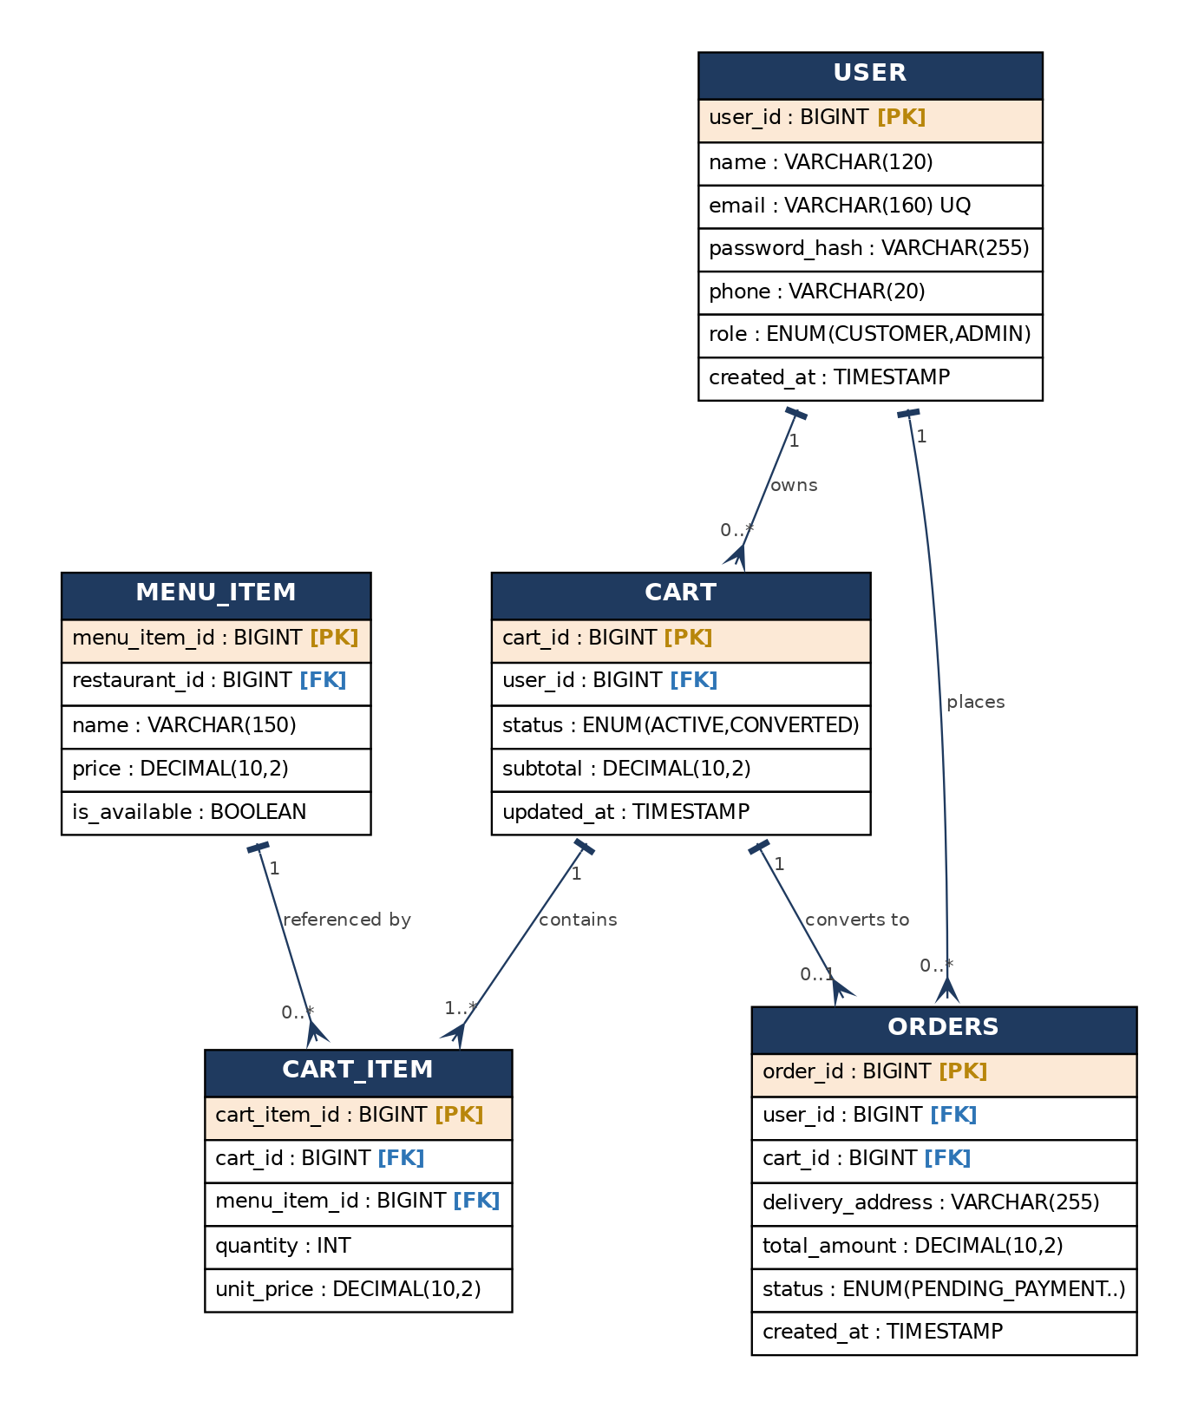
Figure 5.4.2 — ERD for Module 2 (Cart & Order Placement) — Anas Ahmed Hisham
Data dictionary (selected entities).
Entity | Attribute | Type | Notes
CART | cart_id | BIGINT | PK.
CART | status | ENUM | ACTIVE → CONVERTED after checkout.
CART | subtotal | DECIMAL(10,2) | Recomputed by updateCartTotal().
CART_ITEM | cart_item_id | BIGINT | PK.
CART_ITEM | quantity | INT | Validated 1..20 (DT-M2-1).
ORDERS | order_id | BIGINT | PK.
ORDERS | status | ENUM | PENDING_PAYMENT, CONFIRMED, OUT_FOR_DELIVERY, DELIVERED, CANCELLED.
ORDERS | total_amount | DECIMAL(10,2) | Order grand total.

5.4.4 Module 3 — Payment Processing & Delivery Tracking | Imtiaj Ahmed
Core features: Process Payment and Track Delivery. The module owns TRANSACTION, DELIVERY, and DRIVER, and references ORDERS.
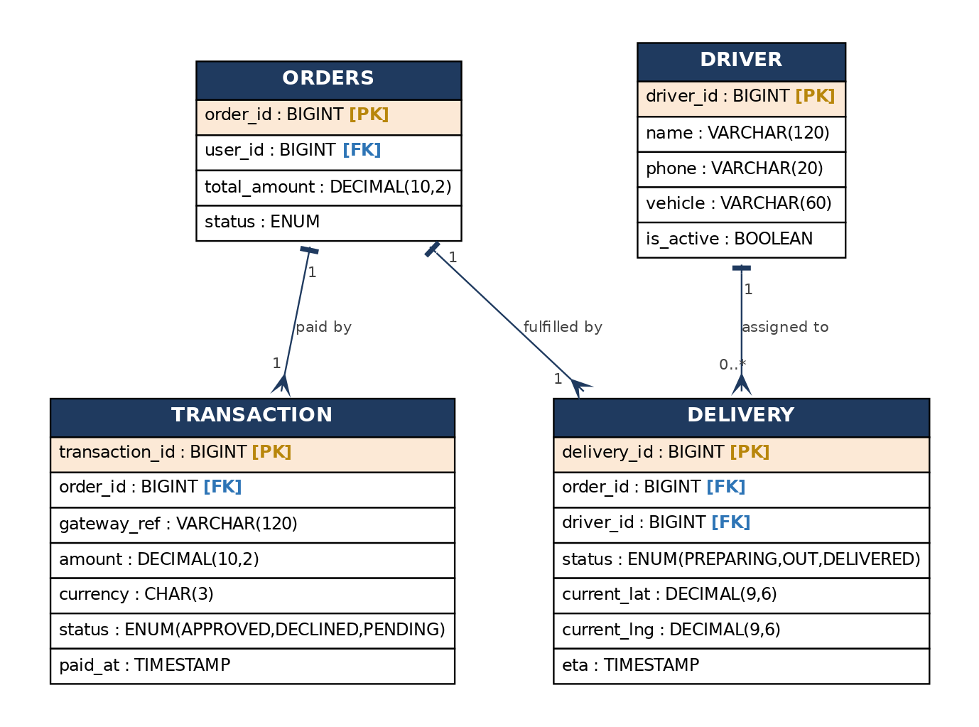
Figure 5.4.3 — ERD for Module 3 (Payment & Delivery Tracking) — Imtiaj Ahmed
Data dictionary (selected entities).
Entity | Attribute | Type | Notes
TRANSACTION | transaction_id | BIGINT | PK.
TRANSACTION | gateway_ref | VARCHAR(120) | Reference returned by Stripe; no card data stored (PCI).
TRANSACTION | status | ENUM | APPROVED, DECLINED, PENDING.
DELIVERY | delivery_id | BIGINT | PK.
DELIVERY | current_lat / current_lng | DECIMAL(9,6) | Live GPS pushed via WebSocket (DT-M3-2).
DELIVERY | eta | TIMESTAMP | From getETA(); shown on tracking screen.
DRIVER | driver_id | BIGINT | PK.
DRIVER | is_active | BOOLEAN | Eligible for dispatch.

5.4.5 Alignment Check — ERD entities ↔ Assignment 1 UML classes
Each ERD entity maps to a class established in the Assignment 1 UML, preserving structural coherence between the data model and the object model.
ERD Entity | Owning Module | Assignment 1 UML Class | Match
USER | M1 | User | ✓
SESSION | M1 | AuthService (createSession) | ✓
RESTAURANT | M1 | Restaurant | ✓
MENU_ITEM | M1 | MenuItem | ✓
CART | M2 | ShoppingCart | ✓
CART_ITEM | M2 | CartItem | ✓
ORDERS | M2 | Order | ✓
TRANSACTION | M3 | Transaction | ✓
DELIVERY | M3 | DeliveryService / Delivery | ✓
DRIVER | M3 | Driver | ✓

5.5 Interface Viewpoint (Wireframes) [Task 4]

5.5.1 Design Concerns
The Interface viewpoint covers the user, hardware, software, and communication interfaces. The system exposes a responsive, mobile-first web UI. Hardware: standard smartphones/desktops; GPS is required on the customer device (delivery radius) and driver device (position reporting). Software: the Stripe REST API v1 (external) is integrated behind StripeGatewayAdapter, and an SMTP/Push provider handles notifications. Communication: REST over HTTPS for synchronous calls, an asynchronous event bus for OrderCreated/PaymentApproved/DeliveryDispatched, and WebSocket for live GPS push. The wireframes below are not mere mockups — every control is annotated with the decision-table action it triggers and the ERD data it reads or writes (the integration constraint of the Final Project).

5.5.2 Module 1 wireframes — Auth & Restaurant Browsing | Mohammed Alsakkaf
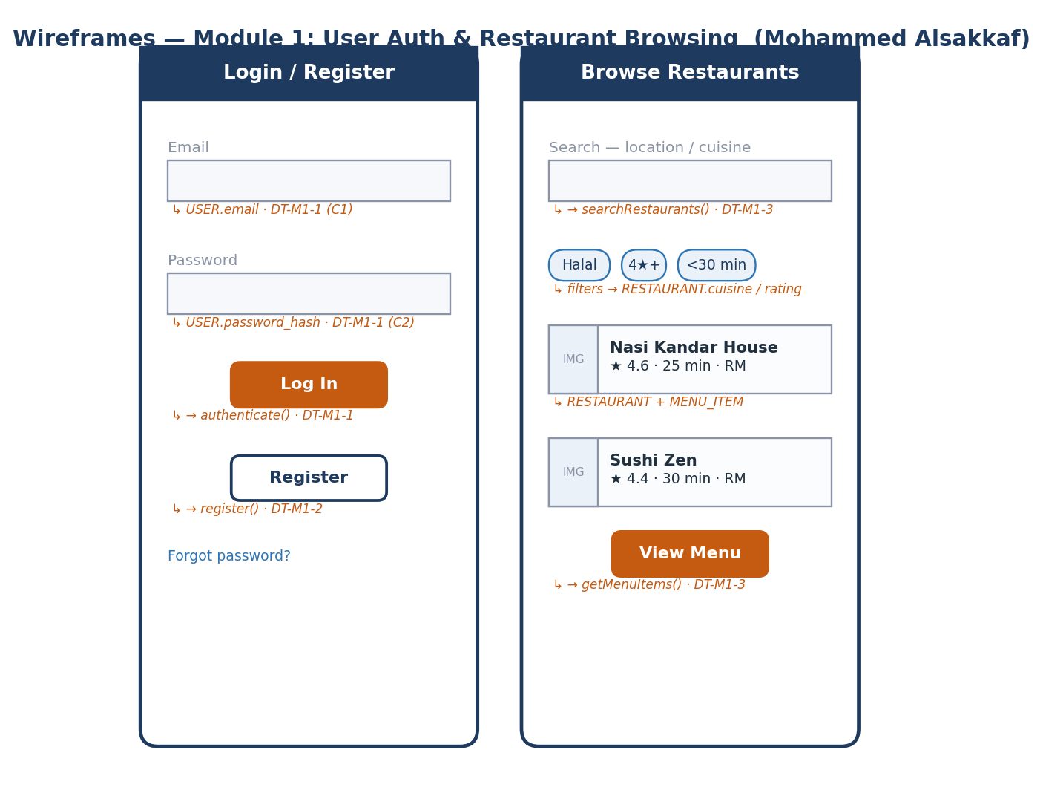
Figure 5.5.1 — Wireframes: Login/Register and Browse Restaurants — Module 1 — Mohammed Alsakkaf

5.5.3 Module 2 wireframes — Shopping Cart & Order Placement | Anas Ahmed Hisham
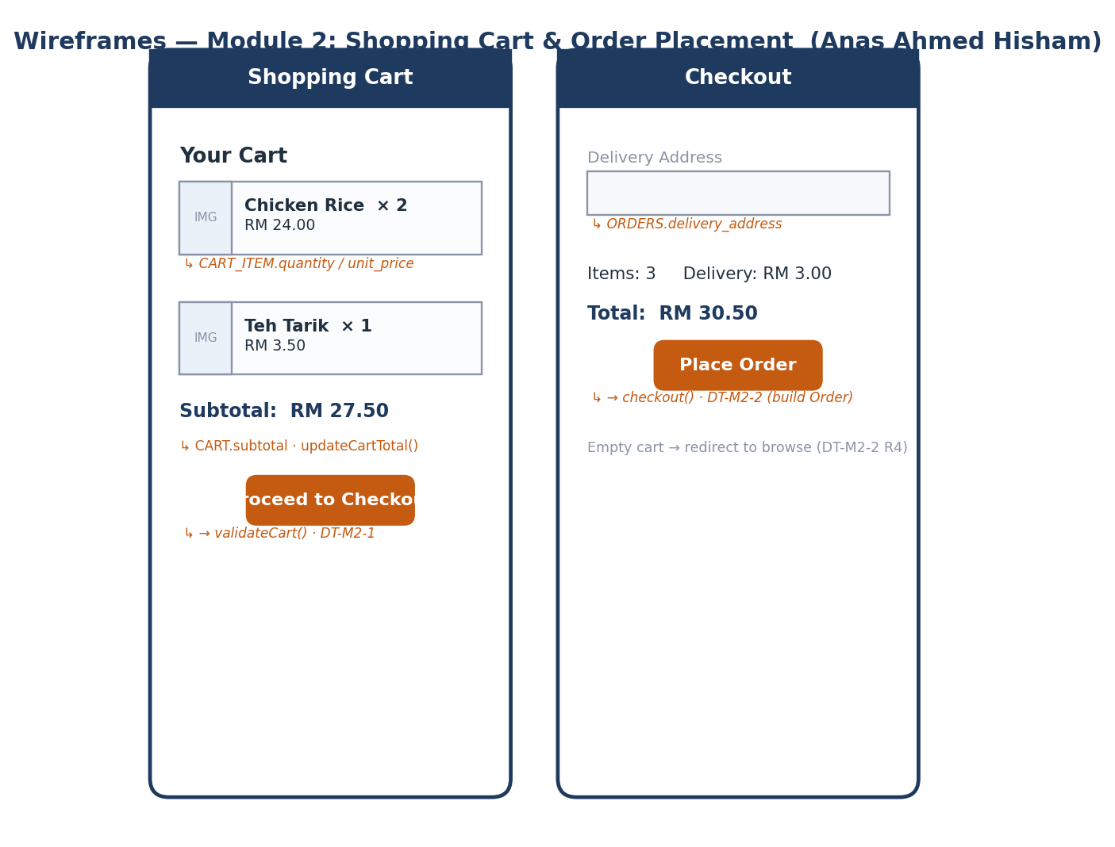
Figure 5.5.2 — Wireframes: Shopping Cart and Checkout — Module 2 — Anas Ahmed Hisham

5.5.4 Module 3 wireframes — Payment & Delivery Tracking | Imtiaj Ahmed
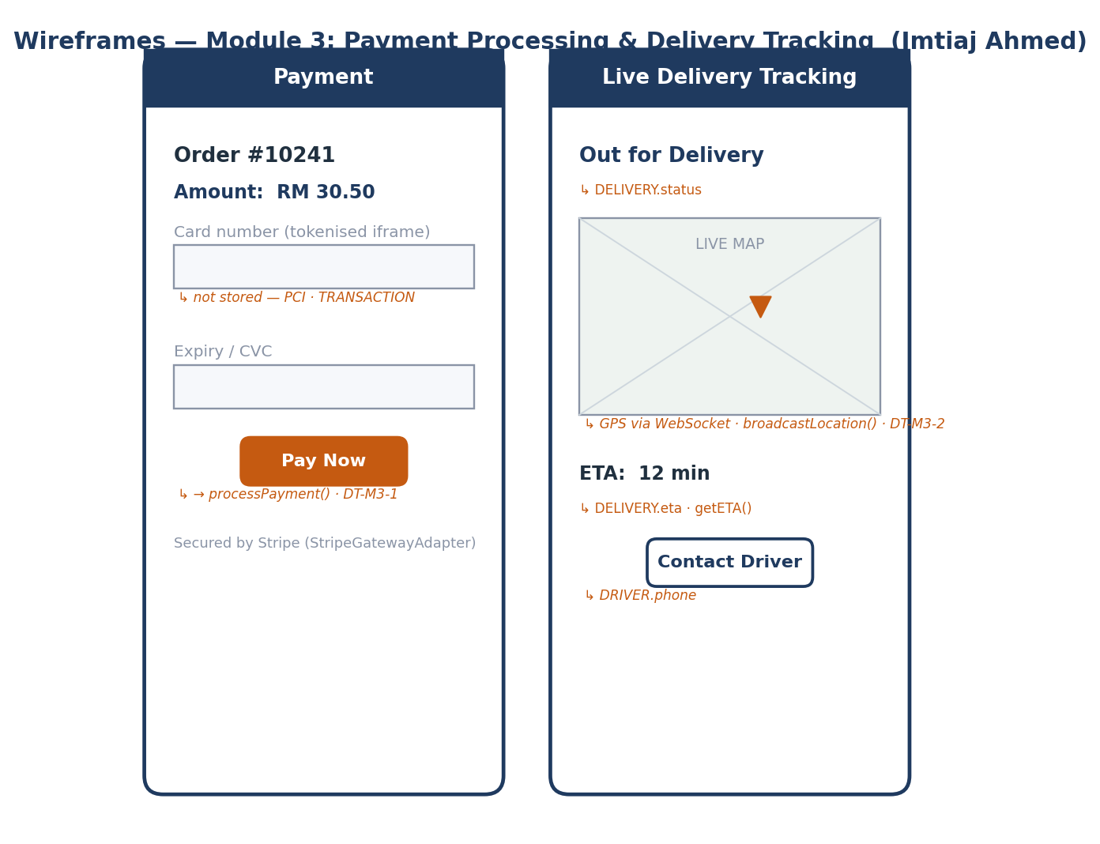
Figure 5.5.3 — Wireframes: Payment and Live Delivery Tracking — Module 3 — Imtiaj Ahmed

5.6 Logical Viewpoint (Design Patterns & Extended Code) [Task 6]

5.6.1 Design Concerns and Synthesis Matrix
The Logical viewpoint elaborates the implemented types — classes and interfaces — and their static relationships within each module. Each module injects exactly one creational, one structural, and one behavioural pattern; the Final Project extends the Assignment 2 code (a second Strategy, the full State set, a second Factory provider, and a second Observer), keeps strict UML↔code coherence, and maps every method back to a sequence message and a decision-table action.
Module / Owner | Creational | Structural | Behavioural
M1 — Mohammed Alsakkaf | Singleton (ConfigurationManager) | Proxy (RestaurantCacheProxy) | Strategy (AuthenticationStrategy)
M2 — Anas Ahmed Hisham | Builder (OrderBuilder) | Facade (CheckoutFacade) | State (OrderState)
M3 — Imtiaj Ahmed | Factory Method (PaymentGatewayFactory) | Adapter (StripeGatewayAdapter) | Observer (TrackingService)

5.6.2 Module 1 — User Auth & Restaurant Browsing | Mohammed Alsakkaf
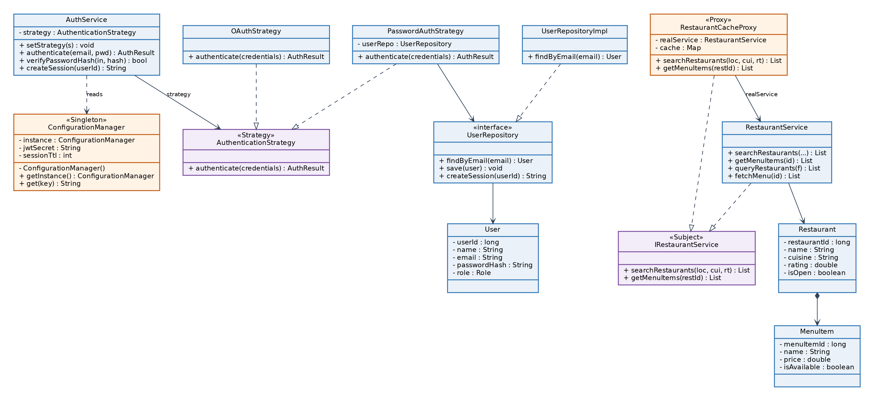
Figure 5.6.1 — Class Diagram: Singleton + Strategy + Proxy — Module 1 — Mohammed Alsakkaf
(a) Creational — Singleton (ConfigurationManager). One shared configuration instance across the Auth Service, with thread-safe lazy initialisation.
// ── Creational: SINGLETON ── ConfigurationManager (§5.6.2a · Fig 5.6-M1)
// One shared config across the Auth Service; thread-safe, lazy, single instance.
public final class ConfigurationManager {
// UML: -instance : ConfigurationManager (the single stored instance)
private static volatile ConfigurationManager instance;
private final Map<String,String> settings = new HashMap<>();

private ConfigurationManager() { // private ctor blocks external 'new'
settings.put("jwtSecret", System.getenv("JWT_SECRET"));
settings.put("sessionTtl", "3600"); // token time-to-live in seconds
}
public static ConfigurationManager getInstance() { // UML: +getInstance()
if (instance == null) { // 1st check — no lock (fast path)
synchronized (ConfigurationManager.class) {
if (instance == null) // 2nd check — double-checked locking
instance = new ConfigurationManager();
}
}
return instance;
}
public String get(String key) { return settings.get(key); } // UML: +get(key)
}
(b) Behavioural — Strategy (AuthenticationStrategy). Password and OAuth login are interchangeable; AuthService is closed to modification but open to new strategies.
// ── Behavioural: STRATEGY ── interchangeable auth algorithms (§5.6.2b · DT-M1-1)
public interface AuthenticationStrategy { // UML: «Strategy»
AuthResult authenticate(AuthRequest credentials);
}
// Concrete strategy #1 — email + password (BCrypt hash check)
public class PasswordAuthStrategy implements AuthenticationStrategy {
private final UserRepository userRepo;
public PasswordAuthStrategy(UserRepository repo) { this.userRepo = repo; }
@Override public AuthResult authenticate(AuthRequest c) { // Seq SD001: strategy.authenticate()
User user = userRepo.findByEmail(c.getEmail()); // DT-M1-1 C2: account exists?
if (user == null) return AuthResult.fail("NO_ACCOUNT"); // → rule R2 (offer register)
boolean ok = BCrypt.checkpw(c.getPassword(), user.getPasswordHash()); // C3
return ok ? AuthResult.success(user) // R3 → A1 (issue JWT)
: AuthResult.fail("BAD_CREDENTIALS"); // R4/R5 → A3/A4
}
}
// Concrete strategy #2 — OAuth 2.0 (added in the Final Project; swappable at runtime)
public class OAuthStrategy implements AuthenticationStrategy {
private final OAuthClient oauth;
public OAuthStrategy(OAuthClient client) { this.oauth = client; }
@Override public AuthResult authenticate(AuthRequest c) {
OAuthProfile p = oauth.exchangeCodeForProfile(c.getOauthCode()); // delegate to provider
if (p == null || !p.isEmailVerified()) return AuthResult.fail("OAUTH_FAILED");
return AuthResult.success(User.fromOAuth(p)); // provision-on-first-login
}
}
// Context — AuthService holds a strategy reference; login/register live here
public class AuthService {
private AuthenticationStrategy strategy; // UML: -strategy
public void setStrategy(AuthenticationStrategy s) { this.strategy = s; }
public AuthResult authenticate(String email, String pwd) {
String secret = ConfigurationManager.getInstance().get("jwtSecret"); // Singleton use
AuthResult r = strategy.authenticate(new AuthRequest(email, pwd)); // Strategy call
if (r.isSuccess()) r.attachToken(createSession(r.getUser().getUserId(), secret));
return r;
}
public AuthResult register(RegisterDTO dto) { // DT-M1-2
if (!dto.isValid()) return AuthResult.fail("FIELD_INVALID"); // R1→A3
if (dto.getPassword().length()<8) return AuthResult.fail("WEAK_PASSWORD"); // R2→A4
try { userRepo.save(User.from(dto)); } // R4→A1 (create USER)
catch (DuplicateEmailException e) { return AuthResult.fail("EMAIL_TAKEN"); } // R3→A2
return authenticate(dto.getEmail(), dto.getPassword());
}
public String createSession(long userId, String secret) { // UML: +createSession()
return JwtUtil.sign(userId, /*ttl*/ 3600, secret); // signed JWT → HttpOnly cookie
}
private UserRepository userRepo;
}
(c) Structural — Proxy (RestaurantCacheProxy). A caching surrogate sharing the subject interface; serves hot queries from cache with a 60-second TTL to hold search P99 under 300 ms.
// ── Structural: PROXY ── caching surrogate over restaurant search (§5.6.2c · DT-M1-3)
public interface IRestaurantService { // UML: «Subject» (shared interface)
List<RestaurantDTO> searchRestaurants(String loc, String cuisine, double rating);
List<MenuItemDTO> getMenuItems(long restaurantId);
}
public class RestaurantCacheProxy implements IRestaurantService { // UML: «Proxy»
private final RestaurantService real; // UML: -realService
private final Map<String,CacheEntry> cache = new ConcurrentHashMap<>();
private static final long TTL_MS = 60_000; // 60s freshness window
public RestaurantCacheProxy(RestaurantService real) { this.real = real; }

@Override public List<RestaurantDTO> searchRestaurants(String loc,String cui,double rt){
String key = loc + "|" + cui + "|" + rt;
CacheEntry hit = cache.get(key);
if (hit != null && !hit.isExpired(TTL_MS)) // DT-M1-3 C1: cache hit?
return hit.data; // R1 → A1 (serve cache)
List<RestaurantDTO> fresh = real.searchRestaurants(loc,cui,rt); // miss → A2 delegate
cache.put(key, new CacheEntry(fresh, System.currentTimeMillis()));
return fresh; // keeps search P99 < 300ms
}
@Override public List<MenuItemDTO> getMenuItems(long restaurantId){
return real.getMenuItems(restaurantId); // menus change rarely
}
}
Coherence validation — Module 1.
Sequence message (Fig 5.7.1) | Class / pattern method (Fig 5.6.1)
getInstance().get('jwtSecret') | ConfigurationManager.getInstance/get() — Singleton
strategy.authenticate(credentials) | AuthenticationStrategy.authenticate() — Strategy
findByEmail(email) | UserRepository.findByEmail()
searchRestaurants(loc, cuisine, rating) | RestaurantCacheProxy.searchRestaurants() — Proxy
real.searchRestaurants(...) | RestaurantService.searchRestaurants()

5.6.3 Module 2 — Shopping Cart & Order Placement | Anas Ahmed Hisham
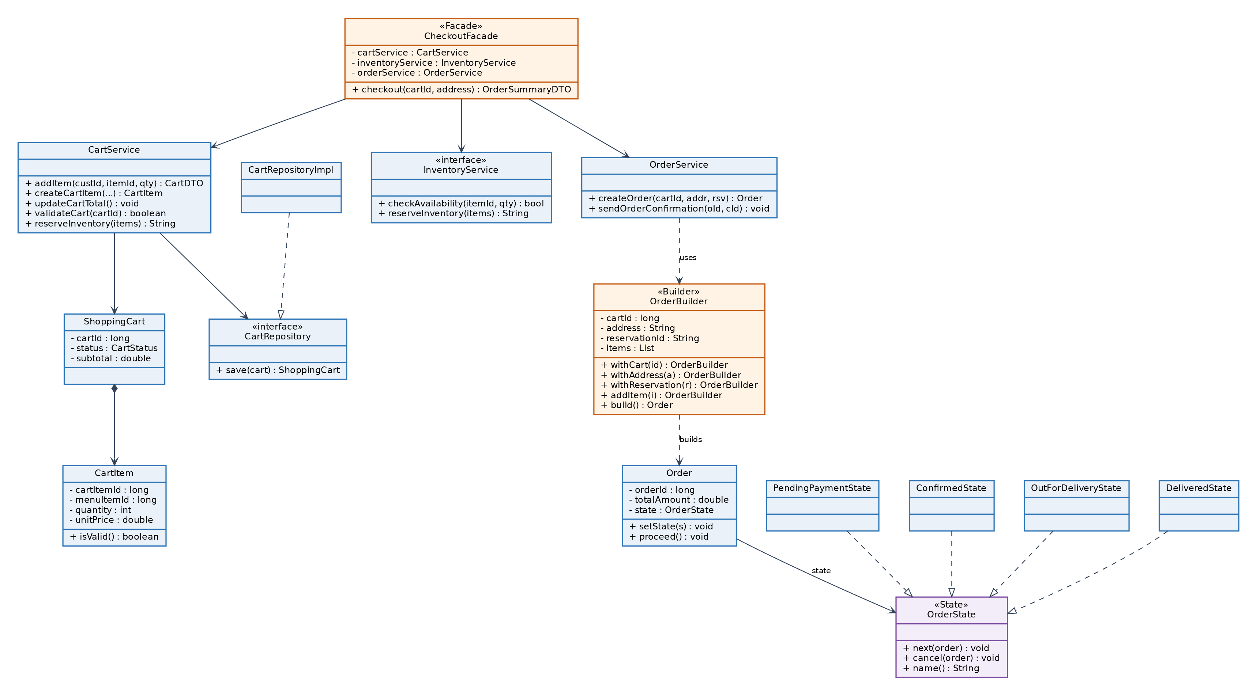
Figure 5.6.2 — Class Diagram: Builder + Facade + State — Module 2 — Anas Ahmed Hisham
(a) Creational — Builder (OrderBuilder). Fluent, step-by-step assembly of a complex Order, keeping construction logic out of Order itself.
// ── Creational: BUILDER ── step-by-step assembly of a complex Order (§5.6.3a)
public class OrderBuilder { // UML: «Builder»
private long cartId;
private String address;
private String reservationId;
private final List<CartItem> items = new ArrayList<>();
public OrderBuilder withCart(long id) { this.cartId = id; return this; } // fluent
public OrderBuilder withAddress(String a) { this.address = a; return this; }
public OrderBuilder withReservation(String r){ this.reservationId = r; return this; }
public OrderBuilder addItem(CartItem i) { this.items.add(i); return this; }
public Order build() { // UML: +build() : Order
if (items.isEmpty()) throw new EmptyCartException(cartId); // guard
Order order = new Order(cartId, address, reservationId, items);
order.setState(new PendingPaymentState()); // initial State (see State pattern)
return order;
}
}
(b) Structural — Facade (CheckoutFacade). One checkout() entry point over the cart, inventory, and order subsystems.
// ── Structural: FACADE ── one checkout() over three subsystems (§5.6.3b · DT-M2-2)
public class CheckoutFacade { // UML: «Facade»
private final CartService cartService;
private final InventoryService inventoryService;
private final OrderService orderService;
public CheckoutFacade(CartService c, InventoryService i, OrderService o){
this.cartService=c; this.inventoryService=i; this.orderService=o;
}
public OrderSummaryDTO checkout(long cartId, String address){ // Seq SD002
if (!cartService.validateCart(cartId)) // DT-M2-2 C1
throw new EmptyCartException(cartId); // R1 → A4 (redirect)
if (address == null || address.isBlank()) // C2
throw new MissingAddressException(); // R2 → A3
String reservationId = // C3 (may throw)
inventoryService.reserveInventory(cartService.getItems(cartId));
Order order = orderService.createOrder(cartId, address, reservationId); // R4 → A1
orderService.sendOrderConfirmation(order.getId(), order.getUserId()); // async
return OrderSummaryDTO.from(order);
}
}
(c) Behavioural — State (OrderState). The order’s legal transitions live in state classes; Order.proceed() does the right thing without large conditionals. The full lifecycle is modelled in Figure 5.8.2.
// ── Behavioural: STATE ── order changes behaviour with its lifecycle (§5.6.3c)
public interface OrderState { // UML: «State»
void next(Order order); // legal forward transition
void cancel(Order order); // cancellation rule (state-specific)
String name();
}
public class PendingPaymentState implements OrderState {
public void next(Order o) { o.setState(new ConfirmedState()); } // on payment approved
public void cancel(Order o) { o.setState(new CancelledState()); } // on failure/timeout
public String name() { return "PENDING_PAYMENT"; }
}
public class ConfirmedState implements OrderState {
public void next(Order o) { o.setState(new OutForDeliveryState()); } // driver dispatched
public void cancel(Order o) { throw new IllegalStateException("Confirmed order cannot cancel"); }
public String name() { return "CONFIRMED"; }
}
public class OutForDeliveryState implements OrderState {
public void next(Order o) { o.setState(new DeliveredState()); } // driver completes
public void cancel(Order o) { throw new IllegalStateException("In-transit order cannot cancel"); }
public String name() { return "OUT_FOR_DELIVERY"; }
}
public class DeliveredState implements OrderState { // terminal state
public void next(Order o) { /* no-op: already delivered */ }
public void cancel(Order o) { throw new IllegalStateException("Delivered order cannot cancel"); }
public String name() { return "DELIVERED"; }
}
public class CancelledState implements OrderState { // terminal state
public void next(Order o) { throw new IllegalStateException("Cancelled order cannot proceed"); }
public void cancel(Order o) { /* no-op */ }
public String name() { return "CANCELLED"; }
}
public class Order {
private OrderState state; // UML: -state : OrderState
public void setState(OrderState s) { this.state = s; }
public void proceed() { state.next(this); } // delegates to current state — no if/else
public String status() { return state.name(); }
}
Coherence validation — Module 2.
Sequence message (Fig 5.7.2) | Class / pattern method (Fig 5.6.2)
checkout(cartId, address) | CheckoutFacade.checkout() — Facade
validateCart(cartId) | CartService.validateCart()
reserveInventory(items) | InventoryService.reserveInventory()
withCart()…build() | OrderBuilder.build() — Builder
setState(PendingPaymentState) | Order.setState() — State

5.6.4 Module 3 — Payment Processing & Delivery Tracking | Imtiaj Ahmed
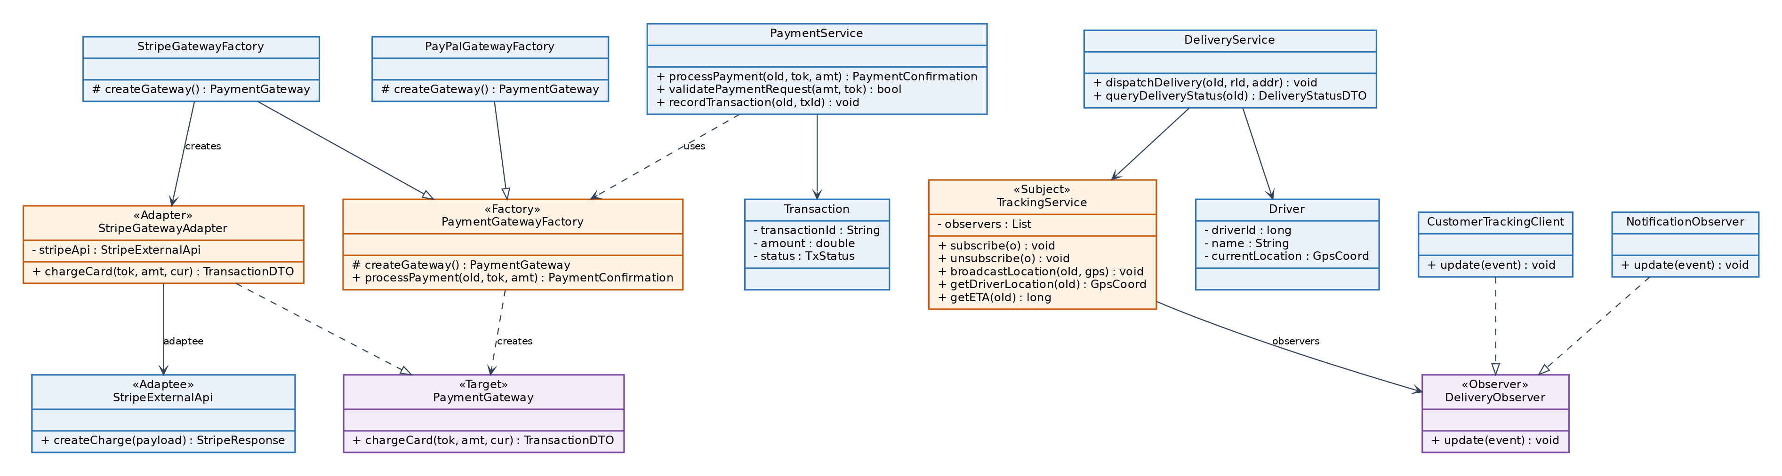
Figure 5.6.3 — Class Diagram: Factory Method + Adapter + Observer — Module 3 — Imtiaj Ahmed
(a) Creational — Factory Method (PaymentGatewayFactory). Subclasses decide which gateway to instantiate; a second provider (PayPal) is added without touching PaymentService.
// ── Creational: FACTORY METHOD ── subclasses pick the gateway (§5.6.4a · DT-M3-1)
public abstract class PaymentGatewayFactory { // UML: «Factory»
protected abstract PaymentGateway createGateway(); // factory method (overridden)
// Template flow shared by every provider:
public PaymentConfirmation processPayment(long orderId, String token, double amount){
if (amount <= 0) throw new InvalidPaymentException("amount"); // DT-M3-1 C2 → A3
PaymentGateway gateway = createGateway(); // Seq SD003: createGateway()
TransactionDTO tx = gateway.chargeCard(token, amount, "MYR"); // C3/C4
return new PaymentConfirmation(orderId, tx);
}
}
public class StripeGatewayFactory extends PaymentGatewayFactory {
@Override protected PaymentGateway createGateway(){
return new StripeGatewayAdapter(new StripeExternalApi()); // wraps 3rd-party (Adapter)
}
}
// Second provider added in the Final Project — no change to PaymentService:
public class PayPalGatewayFactory extends PaymentGatewayFactory {
@Override protected PaymentGateway createGateway(){
return new PayPalGatewayAdapter(new PayPalExternalApi());
}
}
(b) Structural — Adapter (StripeGatewayAdapter). Converts Stripe’s createCharge() to our chargeCard() interface, keeping card data off-platform (PCI DSS).
// ── Structural: ADAPTER ── convert Stripe's API to our interface (§5.6.4b, PCI-safe)
public interface PaymentGateway { // UML: «Target» (what our code expects)
TransactionDTO chargeCard(String token, double amount, String currency);
}
public class StripeExternalApi { // UML: «Adaptee» (3rd-party, unchangeable)
public StripeResponse createCharge(StripePayload p){ /* HTTPS to api.stripe.com */
return new StripeResponse(); }
}
public class StripeGatewayAdapter implements PaymentGateway { // UML: «Adapter»
private final StripeExternalApi stripeApi; // UML: -stripeApi (adaptee)
public StripeGatewayAdapter(StripeExternalApi api){ this.stripeApi = api; }
@Override public TransactionDTO chargeCard(String token,double amount,String currency){
// adapt REQUEST: our args → Stripe payload (amount in the smallest currency unit)
StripePayload payload = new StripePayload(token, (long)(amount*100), currency);
StripeResponse resp = stripeApi.createCharge(payload); // call adaptee (card never stored)
// adapt RESPONSE: Stripe's shape → our TransactionDTO
return new TransactionDTO(resp.getId(), resp.getStatus());
}
}
(c) Behavioural — Observer (TrackingService). Subscribers (customer client, notification service) are pushed every GPS update over WebSocket.
// ── Behavioural: OBSERVER ── push live GPS to all subscribers (§5.6.4c · DT-M3-2)
public interface DeliveryObserver { void update(LocationEvent event); } // UML: «Observer»

public class CustomerTrackingClient implements DeliveryObserver {
@Override public void update(LocationEvent e){ // Seq SD003: WebSocket push
WebSocket.push(e.getOrderId(), e.getGps(), e.getEta()); // animate marker + ETA
}
}
// Second observer added in the Final Project — notifications react to the same events:
public class NotificationObserver implements DeliveryObserver {
@Override public void update(LocationEvent e){
if (e.isArrivingSoon()) Notifier.push(e.getOrderId(), "Your driver is arriving!");
}
}
public class TrackingService { // UML: «Subject»
private final List<DeliveryObserver> observers = new CopyOnWriteArrayList<>();
public void subscribe(DeliveryObserver o) { observers.add(o); } // DT-M3-2 R1
public void unsubscribe(DeliveryObserver o) { observers.remove(o); }
public void broadcastLocation(long orderId, GpsCoord gps){ // every 10s
LocationEvent event = new LocationEvent(orderId, gps, getETA(orderId));
for (DeliveryObserver o : observers) o.update(event); // notify all
}
public long getETA(long orderId){ /* compute from route */ return 12; }
}
Coherence validation — Module 3.
Sequence message (Fig 5.7.3) | Class / pattern method (Fig 5.6.3)
createGateway() | PaymentGatewayFactory.createGateway() — Factory Method
chargeCard(token, amount, 'MYR') | StripeGatewayAdapter.chargeCard() — Adapter
createCharge(payload) | StripeExternalApi.createCharge() (adaptee)
subscribe(client) | TrackingService.subscribe() — Observer
broadcastLocation(orderId, gps) | TrackingService.broadcastLocation()

5.7 Interaction Viewpoint (Sequence Diagrams by Module)

5.7.1 Design Concerns
The Interaction viewpoint shows the exact ordering of messages between objects during each scenario. Every diagram incorporates its module’s patterns, so the runtime collaboration matches the static structure of §5.6 and the decision logic of §5.8.

5.7.2 Design View
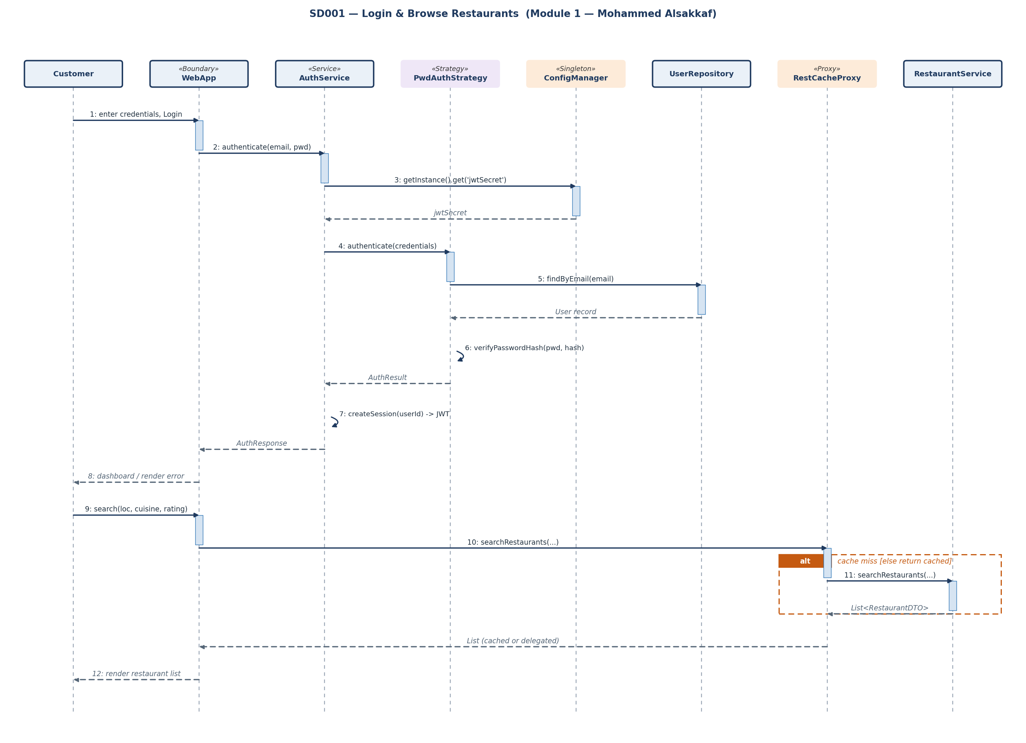
Figure 5.7.1 — Sequence Diagram: Login & Browse (Strategy + Proxy + Singleton) — Module 1 — Mohammed Alsakkaf
The login path runs Customer → WebApp → AuthService, which reads the JWT secret from the ConfigurationManager singleton and delegates verification to PasswordAuthStrategy. The browse path routes through RestaurantCacheProxy, whose alt frame distinguishes a cache hit from a miss that delegates to the real RestaurantService.
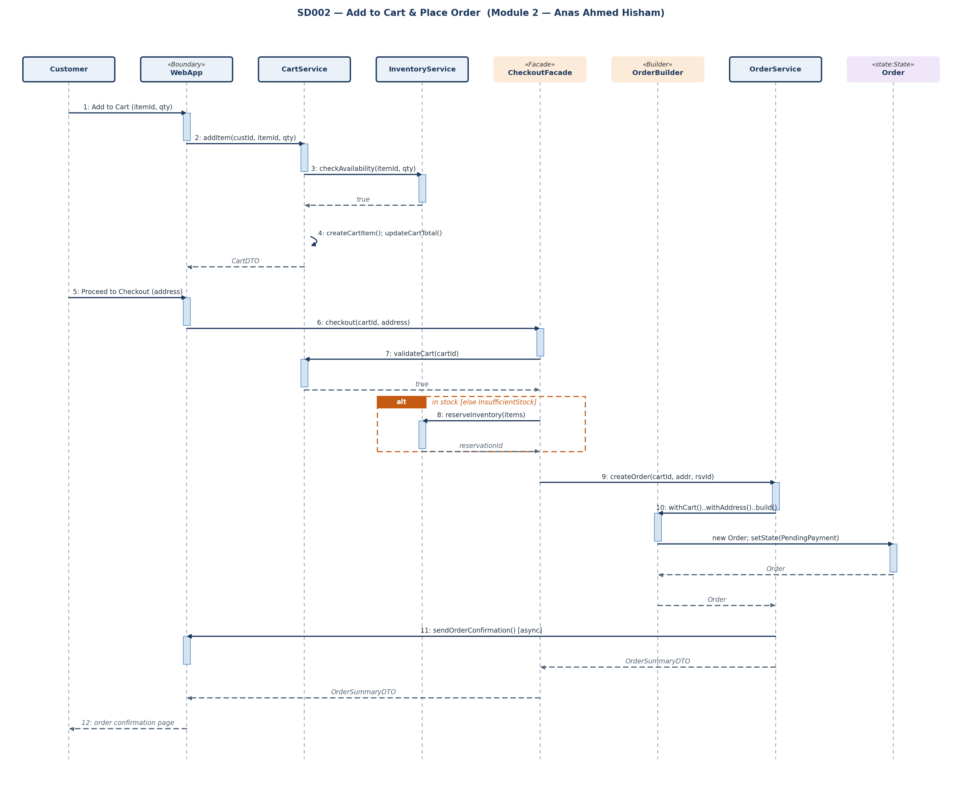
Figure 5.7.2 — Sequence Diagram: Add to Cart & Place Order (Facade + Builder + State) — Module 2 — Anas Ahmed Hisham
CheckoutFacade coordinates validateCart → reserveInventory → createOrder; OrderBuilder assembles the Order, initialised to PendingPaymentState. The InsufficientStockException alternative flow is shown as an alt frame and the confirmation as an async message.
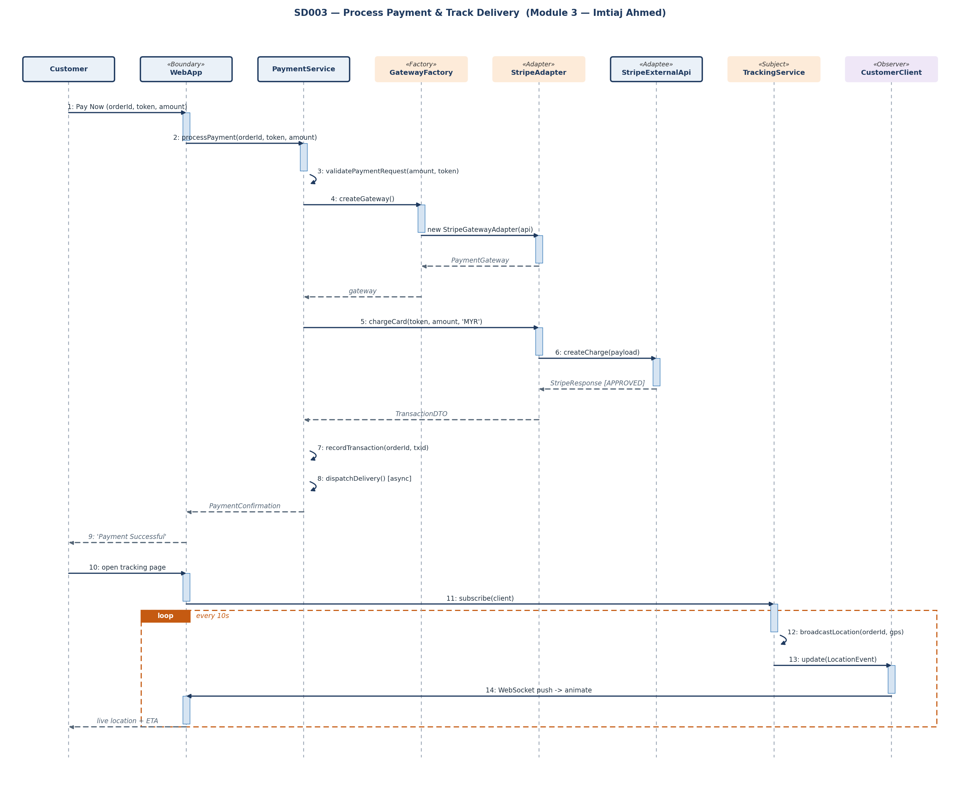
Figure 5.7.3 — Sequence Diagram: Process Payment & Track Delivery (Factory + Adapter + Observer) — Module 3 — Imtiaj Ahmed
PaymentGatewayFactory yields a StripeGatewayAdapter, which translates chargeCard into Stripe’s createCharge. After approval, delivery dispatch is asynchronous, and the tracking loop shows the Observer push every 10 seconds.

5.8 Algorithm Viewpoint (Decision Tables) [Task 3]

5.8.1 Design Concerns
The Algorithm viewpoint charts the exact logic pathways of each module’s key scenarios as limited-entry decision tables. Conditions take Y (true), N (false), or – (don’t-care); an X marks each action fired by a rule. The tables are exhaustive over the meaningful condition combinations, including edge cases and alternative flows — if a condition can occur in the real world, it has a defined action. The end-to-end activity diagram (Fig 5.8.1) and the order state machine (Fig 5.8.2) complete the view.

5.8.2 Decision Tables — Module 1 (Auth & Restaurant Browsing) | Mohammed Alsakkaf
DT-M1-1 — User Login (realises UC001 main + alternative flows).
Rule → | R1 | R2 | R3 | R4 | R5
CONDITIONS
C1: Email format valid? | N | Y | Y | Y | Y
C2: Account exists (findByEmail)? | – | N | Y | Y | Y
C3: Password hash matches? | – | – | Y | N | N
C4: Failed attempts < 5? | – | – | – | Y | N
ACTIONS
A1: Issue JWT session, redirect home | – | – | X | – | –
A2: Show ‘Invalid email format’ | X | – | – | – | –
A3: ‘Incorrect email or password’ + increment | – | – | – | X | X
A4: Lock account for 15 minutes | – | – | – | – | X
A5: Offer registration form | – | X | – | – | –
DT-M1-2 — Registration.
Rule → | R1 | R2 | R3 | R4
CONDITIONS
C1: All required fields valid? | N | Y | Y | Y
C2: Password ≥ 8 characters? | – | N | Y | Y
C3: Email already registered? | – | – | Y | N
ACTIONS
A1: Create USER record, issue JWT | – | – | – | X
A2: ‘This email is already registered’ | – | – | X | –
A3: Field-validation error | X | – | – | –
A4: ‘Password must be ≥ 8 characters’ | – | X | – | –
DT-M1-3 — Browse & Search Restaurants (drives the Proxy cache logic).
Rule → | R1 | R2 | R3 | R4
CONDITIONS
C1: Cache hit for query key? | Y | N | N | N
C2: Results found (non-empty)? | – | N | Y | Y
C3: Restaurant is open? | – | – | Y | N
ACTIONS
A1: Serve cached list (Proxy) | X | – | – | –
A2: Delegate to RestaurantService, populate cache | – | X | X | X
A3: ‘No restaurants — widen radius’ | – | X | – | –
A4: Show ‘Currently Closed’, disable Add-to-Cart | – | – | – | X
A5: Render list / menu | X | – | X | X

5.8.3 Decision Tables — Module 2 (Cart & Order Placement) | Anas Ahmed Hisham
DT-M2-1 — Add Item to Cart.
Rule → | R1 | R2 | R3 | R4
CONDITIONS
C1: Quantity within 1..20? | N | Y | Y | Y
C2: Item available (InventoryService)? | – | N | Y | Y
C3: Item already in cart? | – | – | N | Y
ACTIONS
A1: Create CartItem, updateCartTotal() | – | – | X | –
A2: Increment existing quantity, updateCartTotal() | – | – | – | X
A3: ‘Item currently unavailable’ | – | X | – | –
A4: ‘Enter a quantity between 1 and 20’ | X | – | – | –
DT-M2-2 — Place Order / Checkout.
Rule → | R1 | R2 | R3 | R4
CONDITIONS
C1: Cart non-empty (validateCart)? | N | Y | Y | Y
C2: Delivery address provided? | – | N | Y | Y
C3: All items in stock (reserveInventory)? | – | – | N | Y
ACTIONS
A1: Build Order (PENDING_PAYMENT), convert cart, async confirm, go to payment | – | – | – | X
A2: Throw InsufficientStockException, prompt adjust | – | – | X | –
A3: Prompt to enter delivery address | – | X | – | –
A4: Redirect to browse (‘Your cart is empty’) | X | – | – | –

5.8.4 Decision Tables — Module 3 (Payment & Delivery Tracking) | Imtiaj Ahmed
DT-M3-1 — Process Payment.
Rule → | R1 | R2 | R3 | R4 | R5
CONDITIONS
C1: Order status = PENDING_PAYMENT? | N | Y | Y | Y | Y
C2: Amount valid & non-zero? | – | N | Y | Y | Y
C3: Gateway timeout / error? | – | – | Y | N | N
C4: Charge APPROVED? | – | – | – | Y | N
ACTIONS
A1: Record APPROVED, Order→CONFIRMED, dispatch, show success | – | – | – | X | –
A2: ‘Payment declined’, prompt alternate method | – | – | – | – | X
A3: Reject ‘Invalid payment request’ | – | X | – | – | –
A4: Mark PENDING, reconcile (no double charge) | – | – | X | – | –
A5: Reject ‘Order not payable’ | X | – | – | – | –
DT-M3-2 — Track Delivery.
Rule → | R1 | R2 | R3 | R4
CONDITIONS
C1: Payment confirmed & driver assigned? | N | Y | Y | Y
C2: Order already delivered? | – | Y | N | N
C3: GPS signal available? | – | – | Y | N
ACTIONS
A1: Subscribe observer, stream GPS every 10 s, update ETA | – | – | X | –
A2: Show ‘Last known location’, attempt reconnect | – | – | – | X
A3: Set DELIVERED, prompt to rate driver | – | X | – | –
A4: Show ‘Awaiting driver assignment’ | X | – | – | –

5.8.5 Activity & State Models (end-to-end)
The activity diagram traces the principal decision points — cart validity, stock availability, and charge approval — each failure branch mapping to an alternative/exception flow above. The state machine documents the legal order transitions enforced by the State pattern (§5.6.3).
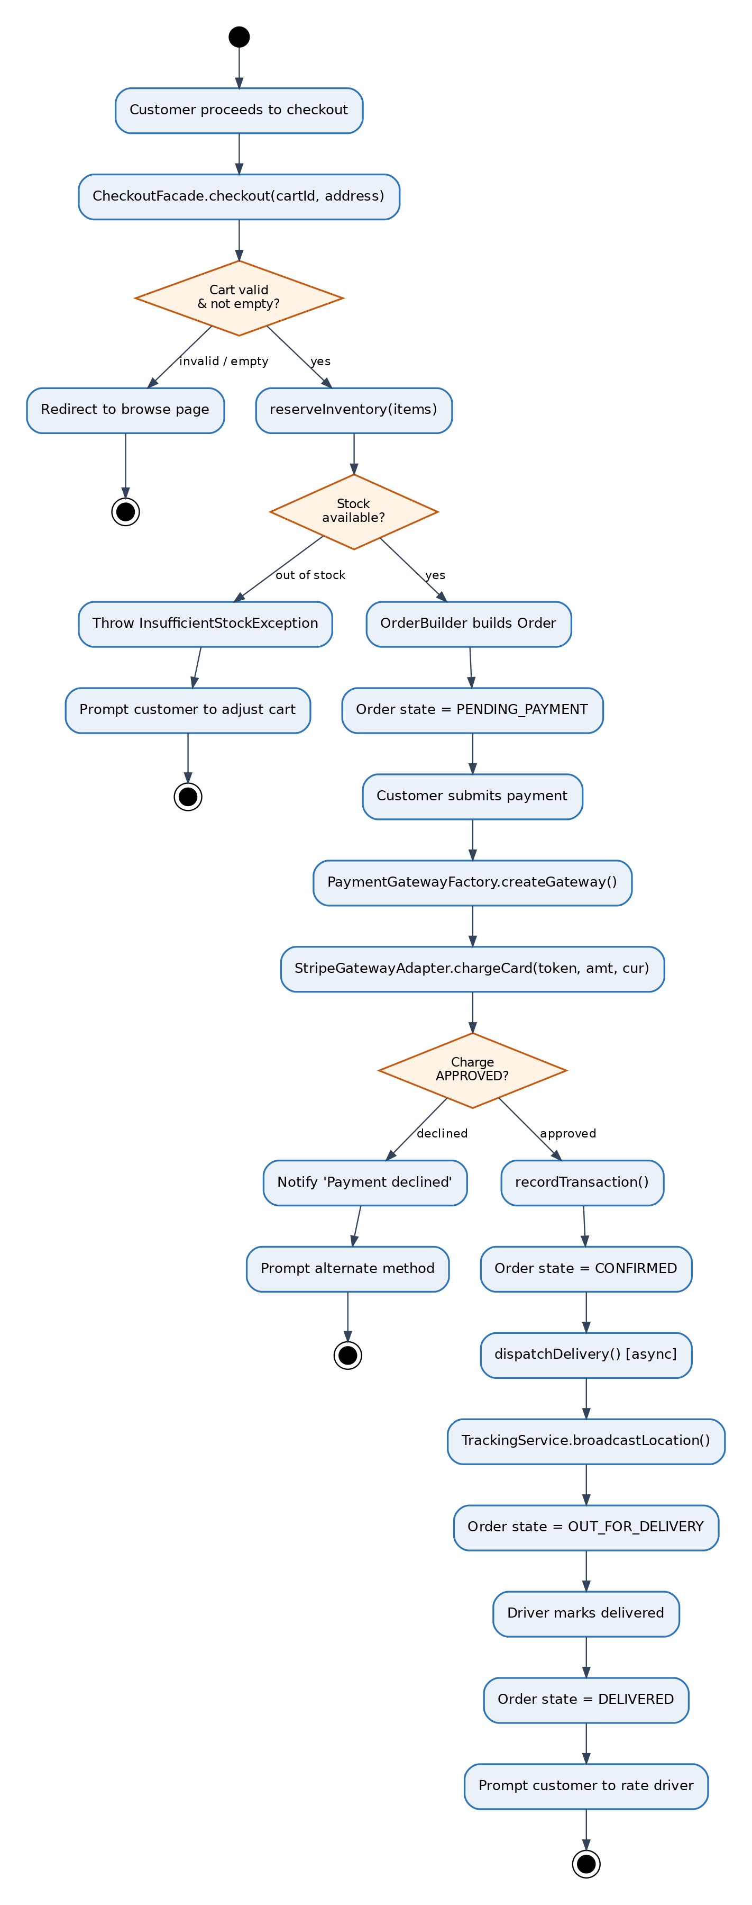
Figure 5.8.1 — Activity Diagram: End-to-End Order to Delivery
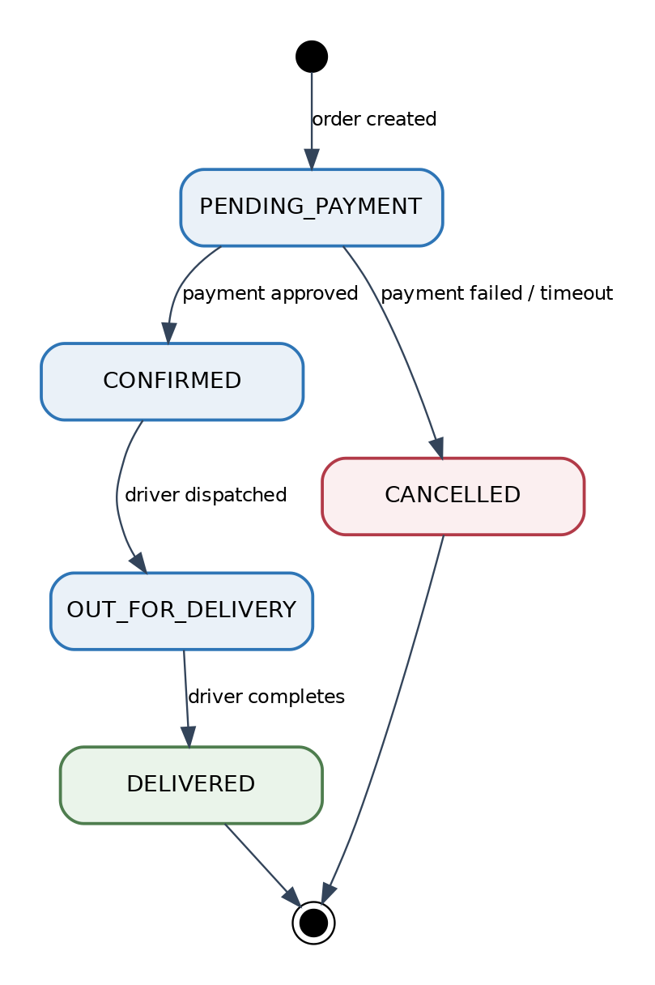
Figure 5.8.2 — State Machine: Order Lifecycle (realised by the State pattern, §5.6.3)

6. Traceability — The Red Thread
The Final Project demands mathematical alignment from the user’s screen down to the compiler: if an attribute exists in the UI, it must exist in the logic, the pattern, and the code. Each matrix below traces every interface control (§5.5) through its decision-table rule (§5.8) and design pattern (§5.6) to the executable method that runs it.

6.1 Module 1 — Mohammed Alsakkaf
UI control (Wireframe §5.5) | Decision Table (§5.8) | Design Pattern (§5.6) | Execution Code method
‘Log In’ button | DT-M1-1 → A1/A3 | Strategy + Singleton | AuthService.authenticate() → PasswordAuthStrategy.authenticate(); ConfigurationManager.getInstance().get()
‘Register’ button | DT-M1-2 → A1 | Repository | AuthService.register(); UserRepository.save()
Search field + filter chips | DT-M1-3 → A1/A2 | Proxy | RestaurantCacheProxy.searchRestaurants() → RestaurantService.searchRestaurants()
‘View Menu’ button | DT-M1-3 → A5 | Proxy | RestaurantCacheProxy.getMenuItems()
Restaurant / menu card (data) | display (ERD) | — | RestaurantDTO / MenuItemDTO (RESTAURANT, MENU_ITEM)

6.2 Module 2 — Anas Ahmed Hisham
UI control (Wireframe §5.5) | Decision Table (§5.8) | Design Pattern (§5.6) | Execution Code method
‘Add to Cart’ button | DT-M2-1 → A1/A2 | (Cart domain) | CartService.addItem(); InventoryService.checkAvailability()
‘Proceed to Checkout’ button | DT-M2-2 → A1 | Facade | CheckoutFacade.checkout()
‘Place Order’ button | DT-M2-2 → A1 | Facade + Builder + State | CheckoutFacade.checkout(); OrderBuilder.build(); Order.setState(PendingPaymentState)
Subtotal / totals (data) | display (ERD) | — | CartService.updateCartTotal() (CART.subtotal)

6.3 Module 3 — Imtiaj Ahmed
UI control (Wireframe §5.5) | Decision Table (§5.8) | Design Pattern (§5.6) | Execution Code method
‘Pay Now’ button | DT-M3-1 → A1/A2 | Factory Method + Adapter | PaymentGatewayFactory.createGateway(); StripeGatewayAdapter.chargeCard()
Tokenised card iframe (data) | DT-M3-1 (PCI) | Adapter | StripeExternalApi.createCharge() — card never stored (TRANSACTION)
Live map + ETA (data) | DT-M3-2 → A1 | Observer | TrackingService.broadcastLocation(); CustomerTrackingClient.update()
‘Contact Driver’ button | DT-M3-2 | — | DRIVER.phone (ERD)
Red-thread guarantee: every wireframe control resolves to a decision-table rule, a design pattern, and a concrete method — no orphan UI, no unreachable logic, no undefined condition.

7. User Interface Design
This section consolidates the user-facing design of §5.5. The system follows a clean, mobile-first visual language with a single prominent primary action per screen, persistent cart visibility, and continuous status feedback during payment and delivery.
Screen | Key elements | Primary action
Login / Register | Email and password fields; toggle to registration; forgot-password link. | Log In
Browse Restaurants | Search bar, filter chips (cuisine, rating, ETA), result cards with rating and ETA. | View Menu
Menu | Items grouped by category with price, description, and dietary labels. | Add to Cart
Cart | Line items with quantity steppers, subtotal, delivery fee, and total. | Proceed to Checkout
Payment | Tokenised PCI-compliant card iframe; order summary; secure indicator. | Pay Now
Tracking | Live map with driver marker, status banner, ETA countdown, contact-driver button. | Contact Driver

8. Appendices

8.1 Appendix A — Module Assignment & Pattern Matrix
Member | Module | Patterns Applied | Sections
Mohammed Alsakkaf | M1 — User Auth & Restaurant Browsing | Singleton, Proxy, Strategy | 5.4.2, 5.5.2, 5.6.2, 5.7.2, 5.8.2, 6.1
Anas Ahmed Hisham | M2 — Shopping Cart & Order Placement | Builder, Facade, State | 5.4.3, 5.5.3, 5.6.3, 5.7.2, 5.8.3, 6.2
Imtiaj Ahmed | M3 — Payment Processing & Delivery Tracking | Factory Method, Adapter, Observer | 5.4.4, 5.5.4, 5.6.4, 5.7.2, 5.8.4, 6.3

8.2 Appendix B — Group Work Contributions
Name | Role | Contribution | %
Mohammed Alsakkaf | Lead Architect & Project Manager | M1 viewpoints (ERD, decision tables, wireframes, extended code), document consolidation, traceability, coherence validation. | 44%
Anas Ahmed Hisham | System Analyst | M2 viewpoints (ERD, decision tables, wireframes, extended code), checkout flow, order state machine. | 28%
Imtiaj Ahmed | Interface Designer | M3 viewpoints (ERD, decision tables, wireframes, extended code), payment adapter, tracking observer. | 28%

8.3 Appendix C — Project Access & Testing Information
Action required: replace the bracketed placeholders with your team’s real GitHub URLs and live deployment URL before submission/presentation. The credentials below are example test accounts — align them with your seeded database.

GitHub Repository
- Full project: [ https://github.com/GroupHub/online-food-delivery ]
- Frontend: [ https://github.com/GroupHub/online-food-delivery-frontend ]
- Backend: [ https://github.com/GroupHub/online-food-delivery-backend ]
Public System Access (live frontend)
- Live URL: [ https://online-food-delivery-grouphub.vercel.app ]
Test Credentials (all roles)
Role | Username / Email | Password
Customer | customer@foodhub.test | Customer@123
Admin | admin@foodhub.test | Admin@123
Delivery Driver | driver@foodhub.test | Driver@123

8.4 Appendix D — Final QA Flight Check
Final Project requirement | Status
Individual work (Tasks 2, 3, 4, 6) explicitly labelled with member name and module | ✓ Yes
Comprehensive ERDs per module; entities align with Assignment 1 UML classes (§5.4.5) | ✓ Yes
Decision tables cover every condition combination, including edge/alternative flows; no ambiguity | ✓ Yes
Wireframes map every control to a decision-table action and ERD data (§5.5, §6) | ✓ Yes
Extended code retains the Creational/Structural/Behavioural triad; syntax-highlighted, heavily commented | ✓ Yes
Global architectural style justified against non-functional requirements (§5.3) | ✓ Yes
Red-thread traceability UI → Decision Table → Pattern → Code complete (§6) | ✓ Yes
Single consolidated report; all diagrams, code, and documentation inline; no fragmentation | ✓ Yes

